DEFAULT Constraint

🌟 Definition
# Source: AI Source: Provided by: [Data Path: Persons Table -> ID Column: 1, Name_En Column: Motasem Essam] -> From: [ChatGPT] on [6/10/2026]
A DEFAULT Constraint is a rule that automatically assigns a predefined value to a column when no value is provided during an INSERT operation.
Instead of storing NULL or requiring the user to enter a value, the database uses the default value.

🎯 Purpose
# Source: AI Source: Provided by: [Data Path: Persons Table -> ID Column: 1, Name_En Column: Motasem Essam] -> From: [ChatGPT] on [6/10/2026]
The DEFAULT constraint is used to:
- Automatically populate columns
- Reduce data entry effort
- Ensure consistent values
- Avoid unnecessary NULL values
- Enforce business defaults

🧠 Simple Example
# Source: AI Source: Provided by: [Data Path: Persons Table -> ID Column: 1, Name_En Column: Motasem Essam] -> From: [ChatGPT] on [6/10/2026]
Suppose a new user account is created.
If no status is provided:
Status = Active
The database automatically inserts:
Active

📚 Real-World Examples
# Source: AI Source: Provided by: [Data Path: Persons Table -> ID Column: 1, Name_En Column: Motasem Essam] -> From: [ChatGPT] on [6/10/2026]
1. User Status
Default:
Active

2. Product Stock
Default:
0

3. Order Status
Default:
Pending

4. Country
Default:
Egypt

5. Registration Date
Default:
Current Date

🗄️ SQL Example
# Source: AI Source: Provided by: [Data Path: Persons Table -> ID Column: 1, Name_En Column: Motasem Essam] -> From: [ChatGPT] on [6/10/2026]
User Table
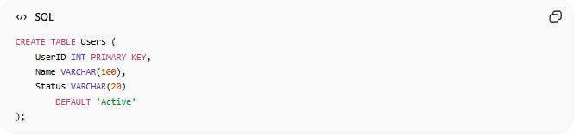
CREATE TABLE Users (
UserID INT PRIMARY KEY,
Name VARCHAR(100),
Status VARCHAR(20)
DEFAULT 'Active'
);

Insert Without Status
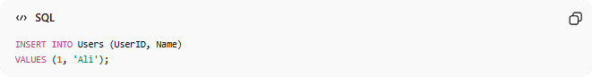
INSERT INTO Users (UserID, Name)
VALUES (1, 'Ali');

Result
UserID | Name | Status
1 | Ali | Active
The database automatically used the default value.

📊 Database Example
# Source: AI Source: Provided by: [Data Path: Persons Table -> ID Column: 1, Name_En Column: Motasem Essam] -> From: [ChatGPT] on [6/10/2026]
Table Definition
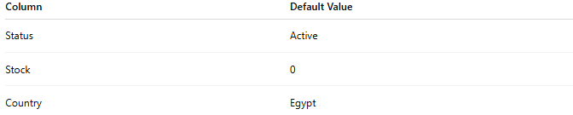
Column | Default Value
Status | Active
Stock | 0
Country | Egypt

Insert
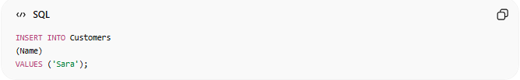
INSERT INTO Customers
(Name)
VALUES ('Sara');

Stored Record
Name | Country
Sara | Egypt
Country was assigned automatically.

🔢 Characteristics of DEFAULT
# Source: AI Source: Provided by: [Data Path: Persons Table -> ID Column: 1, Name_En Column: Motasem Essam] -> From: [ChatGPT] on [6/10/2026]
A DEFAULT constraint:
- Provides an automatic value
- Is used only when no value is supplied
- Can be used with numbers, text, dates, and booleans
- Improves consistency

🗄️ Text Default Example
# Source: AI Source: Provided by: [Data Path: Persons Table -> ID Column: 1, Name_En Column: Motasem Essam] -> From: [ChatGPT] on [6/10/2026]
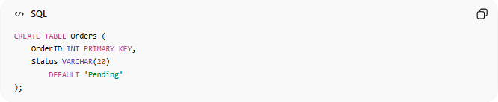
CREATE TABLE Orders (
OrderID INT PRIMARY KEY,
Status VARCHAR(20)
DEFAULT 'Pending'
);

Insert
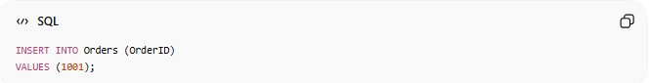
INSERT INTO Orders (OrderID)
VALUES (1001);

Result
OrderID | Status
1001 | Pending

🗄️ Numeric Default Example
# Source: AI Source: Provided by: [Data Path: Persons Table -> ID Column: 1, Name_En Column: Motasem Essam] -> From: [ChatGPT] on [6/10/2026]
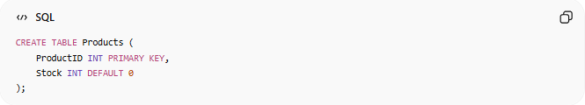
CREATE TABLE Products (
ProductID INT PRIMARY KEY,
Stock INT DEFAULT 0
);

Insert
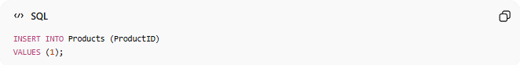
INSERT INTO Products (ProductID)
VALUES (1);

Result
ProductID | Stock
1 | 0

🗄️ Date Default Example
# Source: AI Source: Provided by: [Data Path: Persons Table -> ID Column: 1, Name_En Column: Motasem Essam] -> From: [ChatGPT] on [6/10/2026]
Automatically store the current date.
MySQL
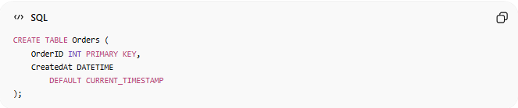
CREATE TABLE Orders (
OrderID INT PRIMARY KEY,
CreatedAt DATETIME
DEFAULT CURRENT_TIMESTAMP
);

Insert
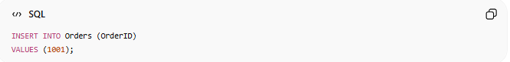
INSERT INTO Orders (OrderID)
VALUES (1001);

Result
OrderID | CreatedAt
1001 | Current Date & Time

🌍 Online Store Example
Products Table
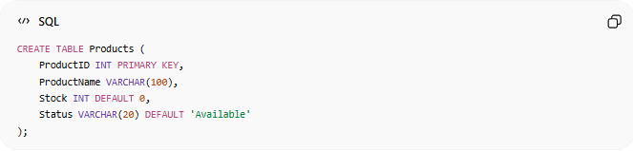
CREATE TABLE Products (
ProductID INT PRIMARY KEY,
ProductName VARCHAR(100),
Stock INT DEFAULT 0,
Status VARCHAR(20) DEFAULT 'Available'
);

Insert
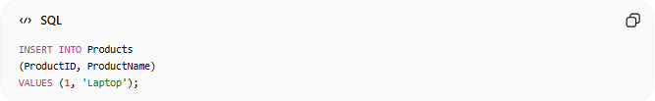
INSERT INTO Products
(ProductID, ProductName)
VALUES (1, 'Laptop');

Stored Data
ProductID | ProductName | Stock | Status
1 | Laptop | 0 | Available
Defaults are applied automatically.

⚠️ DEFAULT vs NOT NULL
# Source: AI Source: Provided by: [Data Path: Persons Table -> ID Column: 1, Name_En Column: Motasem Essam] -> From: [ChatGPT] on [6/10/2026]
DEFAULT
Provides a value automatically.
Example:
Status = Active

NOT NULL
Requires a value to exist.
Example:
Name cannot be NULL.

Comparison
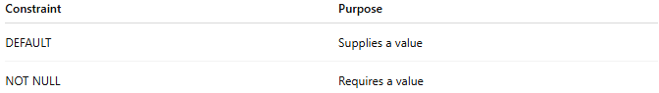
Constraint | Purpose
DEFAULT | Supplies a value
NOT NULL | Requires a value

⚠️ DEFAULT vs NULL
# Source: AI Source: Provided by: [Data Path: Persons Table -> ID Column: 1, Name_En Column: Motasem Essam] -> From: [ChatGPT] on [6/10/2026]
Suppose:
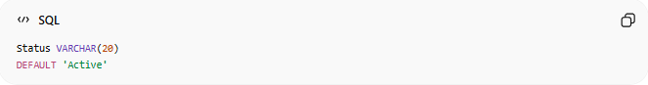
Status VARCHAR(20)
DEFAULT 'Active'

Insert Without Status
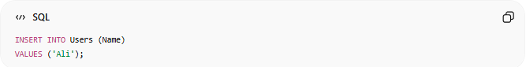
INSERT INTO Users (Name)
VALUES ('Ali');
Result:
Active
(Default is used.)

Insert With NULL
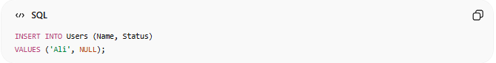
INSERT INTO Users (Name, Status)
VALUES ('Ali', NULL);
Result:
NULL
(Default is NOT used because a value was supplied.)

🔗 DEFAULT with NOT NULL
# Source: AI Source: Provided by: [Data Path: Persons Table -> ID Column: 1, Name_En Column: Motasem Essam] -> From: [ChatGPT] on [6/10/2026]
Often used together.
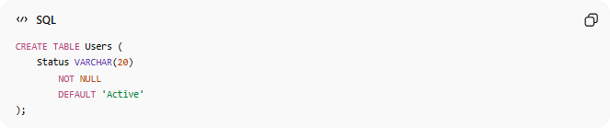
CREATE TABLE Users (
Status VARCHAR(20)
NOT NULL
DEFAULT 'Active'
);
Meaning:
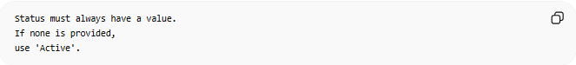
Status must always have a value.
If none is provided,
use 'Active'.

📚 Common DEFAULT Values
# Source: AI Source: Provided by: [Data Path: Persons Table -> ID Column: 1, Name_En Column: Motasem Essam] -> From: [ChatGPT] on [6/10/2026]
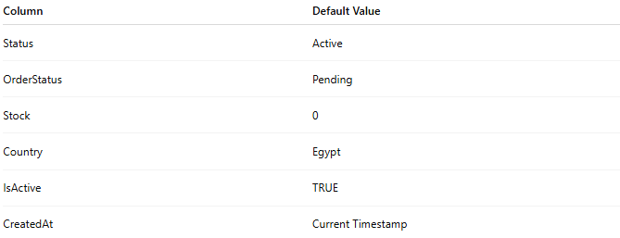
Column | Default Value
Status | Active
OrderStatus | Pending
Stock | 0
Country | Egypt
IsActive | TRUE
CreatedAt | Current Timestamp

🧠 Simple Analogy
# Source: AI Source: Provided by: [Data Path: Persons Table -> ID Column: 1, Name_En Column: Motasem Essam] -> From: [ChatGPT] on [6/10/2026]
Think of a job application form.
If the applicant does not select a country:
Country = Egypt
is automatically filled in.
That automatic value works like a DEFAULT Constraint.

🧭 Summary
# Source: AI Source: Provided by: [Data Path: Persons Table -> ID Column: 1, Name_En Column: Motasem Essam] -> From: [ChatGPT] on [6/10/2026]
A DEFAULT Constraint automatically assigns a predefined value to a column when no value is provided. It helps maintain consistency, reduce manual input, and avoid unnecessary NULL values. Common defaults include Status = Active, Stock = 0, Order Status = Pending, and CreatedAt = Current Timestamp.

